Diagram GPT
Diagram GPT : Link

- User Journey Workflow
- Architectural Diagrams
- Data Flow Diagrams
- Entity Relationship Diagrams

Prompt : Create a user journey diagram for Uber for a new feature of Uber Pool that I want to use. Show both the driver and the end user workflow. Pooling uber is multiple people sharing a ride and ensuring that the drive is efficient, on-time and safe.

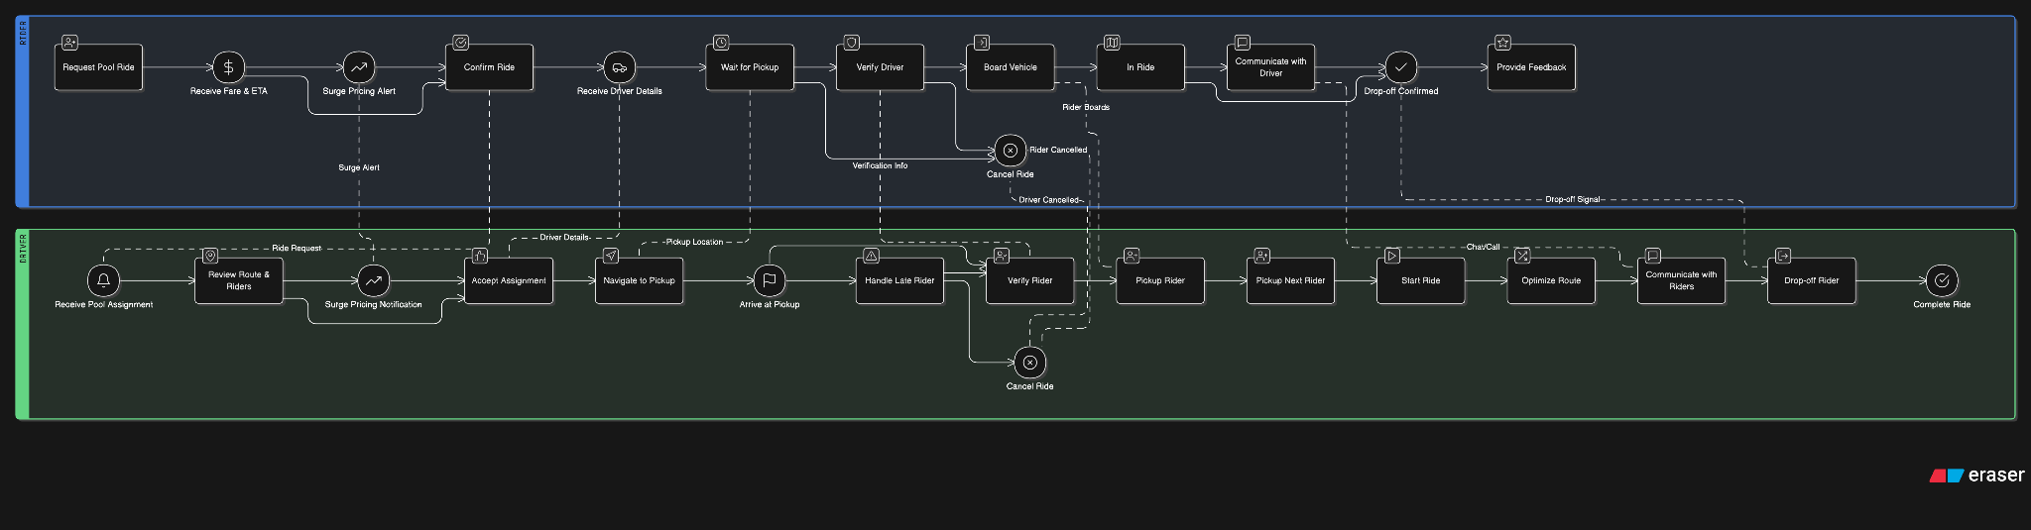

Whimsical
Prompt :
  - Prompt - I am trying to create an SME lending platform. I want to add a feature that will help me enable borrowers refactor the loan that they have borrowed. Please help me create sticky notes to understand the problems of lenders and borrowers for the same.
  - Prompt - I am trying to create an SME lending platform. I want to add a feature that will help me enable borrowers refactor the loan that they have borrowed. Please help me create a mindmap to see potential ways to solve this
  - Prompt - I am trying to create an SME lending platform. I want to add a feature that will help me enable borrowers refactor the loan that they have borrowed. Help me create a sequence diagram that explains the interaction between lender and borrower.

Link : Link

Muro
Product : Link

  - I am working as a product manager on Swiggy where we are trying to add a feature for Bulk ordering for events and parties. Help me create a success metric and goals outline for this feature.

Napkin

N8n
N8N Setup Guide

